A BRIEF HISTORY OF RWANDA
OVERVIEW:
Different tribes, Hutu, Tutsi and Twa, lived peacefully under a succession of Tutsi kings until 1899 when Rwanda became a German colony. When Germany lost World War One, Rwanda was given to the League of Nations and ruled by Belgium. The Hutu tribe established an independent Hutu-led state from 1962 and targeted the Tutsi tribe, discriminating against them and forcing around two million of them into exile to neighbouring countries. While in exile some Tutsis formed the Rwandese Patriotric Front (RPF). In just 100 days in 1994 extremist Hutus in the Government encouraged people across the country to kill Tutsis and moderate Hutus. The RPF liberated Rwanda in July 1994, after more than one million Tutsi and moderate Hutus had been murdered.

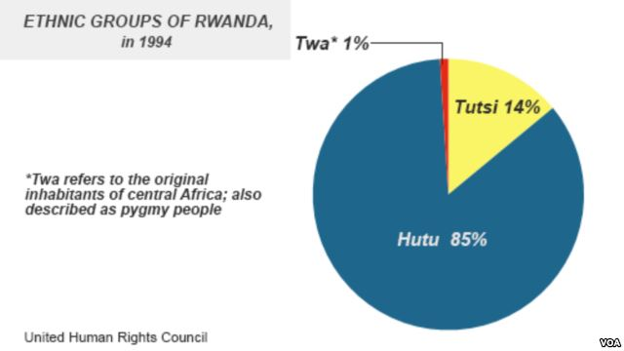
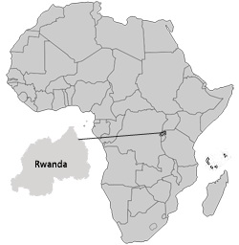
DETAILED HISTORY OF RWANDAN GENOCIDE
All Rwandans share a common language, Kinyarwanda. They have the same cultural tradition and background including a common national mythology, which tells of the origins and historical relationships of their three peoples: the Hutu (85% of the population); the Tutsi (14%); and the Twa, or Pygmy (1%).

The Rwandan myth of origins asserts that the first king of the earth had three sons, GaTWA, GaHUTU,and GaTUTSI. Each was given a pot of milk. Gatwa drank all of his. Gahutu spilled his. But Gatutsi, demonstrating his natural superiority, kept his safe. So the king put Gatutsi in charge of all. The word Hutu originally meant "servant" or "subject" and the word Tutsi meant "rich in cattle." In general, but with many exceptions, the Tutsi were taller and had sharper features. The Hutu (again generally and with many exceptions) were shorter with larger noses and blunter features. Tutsi tended cattle, and were overlords. Hutu farmed the land and were regarded as peasants. It was possible to change one's classification by intermarriage or "social climbing." In effect, the difference between Hutu and Tutsi was one of caste/class rather than ethnicity.
In 1884, a hundred years before the genocide, the European colonial powers began to operate in the Great Lakes section of Africa that includes Rwanda. (1884 was also the year the Dutch took control of South Africa.) Rwanda was initially colonized by the Germans. The peace treaty ending WW I, gave a League of Nations "trusteeship" over the colony to Belgium. The
Tutsi, who looked more European to the colonizers, were seen as natural aristocrats and were favored in government and society. Employing a "divide and rule" strategy, the Belgians used the Tutsi to help them control the Hutu. Identity cards were issued with Hutu and Tutsi as "ethnic" designations in 1926.

WHY WERE THE TUTSI FAVORED?

During the late 1950s, many African colonies became independent. The Belgians turned the government of Rwanda over to the majority Hutu, who promptly reversed the preferences that the Tutsi had enjoyed. After independence in 1962 it was Tutsi children who were excluded from school and Tutsi adults who could not get government jobs.

WHY DID THE HUTU RESENT THE TUTSIS? WHEN THE HUTU GOT POWER IN 1962, WHAT PREFERENCES DID THEY TAKE AWAY FROM THE TUTSIS AND WHY?

From the 1960s onward, there were episodes in which Tutsis massacred Hutus and Hutus massacred Tutsis in both Rwanda and neighboring Burundi, which has a similar class/caste system. Some of the massacres were very large, with 200,000 Hutu and Tutsi being killed in Burundi in 1993. Due to repression and recurring massacres, half the Tutsi population of Rwanda had fled to neighboring countries by 1994. Many Hutu from Burundi, radicalized by the conflict in their own country, had fled to Rwanda.
In 1990 the exiled Tutsi formed a rebel force, the Rwandan Patriotic Front, or RPF, to invade their homeland and win the right of return. This set the stage for the Hutu-dominated Rwandan government to paint all Tutsis as traitors. The government condoned or actually sponsored outbreaks of violence against the Tutsi. The RPF was better trained and had a brilliant general, Paul Kagame. By 1993 the RPF was a real threat to the Hutu-dominated Rwandan government.
A coalition government was announced in 1993 after negotiations in Arusha, Tanzania. The UN passed a resolution creating the UN Assistance Mission for Rwanda (UNAMIR) under a Chapter VI mandate to assist in implementing the Arusha Accords. (Peacekeepers operating under Chapter VI of the U.N. Charter may only use force if they are attacked and only to defend themselves.) General Roméo Dallaire of Canada was appointed Force Commander. He first arrived in Rwanda on an information-gathering mission with little more than a map and an encyclopedia article on Rwanda. Dallaire requested 5,000 peacekeeping troops but was granted only 2,500.
The genocide was planned months or years in advance by Hutu extremists in the army and the government. It was launched in Kigali, the capital of Rwanda, on April 7, 1994 when the plane carrying Rwandan president Habyarimana, and Burundian President Ntaryamira (also a Hutu) was shot down by a hand held, ground to air missile. The genocide ended only when the RPF completed its conquest of the country on July 18, 1994.
GENOCIDE:
the deliberate killing of a large group of people, especially those of a particular ethnic group or nation.

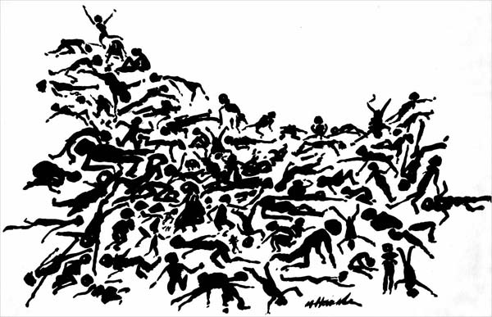
WRITE A 5 SENTENCE SUMMARY EXPLAINING THE EVENTS THAT LED TO THE RWANDAN GENOCIDE:

