Integrated 9 Name:
Mackey/Hofmann
The Odyssey and the Hero’s Journey
assessment

In this unit we have read the epic poem by Homer called The Odyssey. We have followed Odysseus on his great journey. You have studied the Hero’s Journey and learned that it is a common pattern in many stories, books and movies.

Assessment:
- Complete the assessment planning worksheet with a brief description of each of event in Odysseus’ Hero’s Journey. Identify which stage of the Hero’s Journey each event falls under.
- On a large circle, recreate the Hero’s Journey chart. (If you’d like to do a different format, please do so. Just check with one or your teachers first.)
- With pictures, written descriptions and Quotations display Odysseus’s Hero’s Journey. Please use 2-3 quotations per stage (Separation, Initiation, Return). All quotations need to be cited from the text with book and line numbers. (Homer 9.16-18)
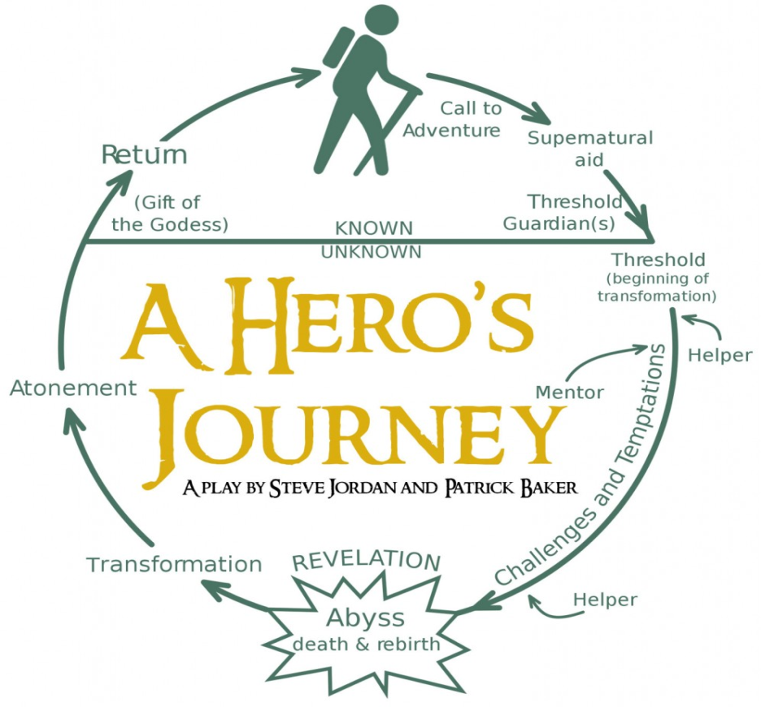

Event from Odysseus’ Journey | What stage of the Hero’s Journey is this event? | Brief Description of Event
Odysseus is called to fight the Trojan War

Odysseus pretends to be crazy when plowing the fields

Trojan War/Defeat of Troy

Cicones

Lotus Eaters

Cyclops

Aeolus/Bag of Winds

Laestrogonians=Giant
Cannibals

Circe

Land of the Dead/Tiresias

Sirens

Scilla

Charybdis

Cattle of the Sun God

Calypso

Odysseus washes up on Phaeacia

Odysseus realizes he is just a man

Odysseus Returns to Ithaca

Reunites with Telemachus

Odysseus controls his anger and devises a plan to take back his world

Kills the Suitors

Reunites with Penelope

