Name
Block
Ancient Greek Culture and Custom
Research Poster Assessment
Assignment:
Create a visually pleasing, thoughtful, creative and well-researched poster about the topic you are assigned. Your goal is to demonstrate a thorough understanding of the topic you are assigned and to create a document to help educate your peers about your topic.

Standards:
- Conduct short as well as more sustained research projects to answer a question (including a self-generated question) or solve a problem; narrow or broaden the inquiry when appropriate; synthesize multiple sources on the subject, demonstrating understanding of the subject under investigation.
- Use technology, including the Internet, to produce, publish, and update individual or shared writing products, taking advantage of technology’s capacity to link to other information and to display information flexibly and dynamically.
- Demonstrate command of the conventions of standard English grammar and usage when writing or speaking.

Requirements:
- Create a visually pleasing poster with all information fitting on the front of one page
- Include a title at the top or center of your page with no larger than 30 pt. font.
- Include 10 pieces of data about your topic. These should be research facts that you put in your own words. No bigger than 14 font. Be creative and purposeful with fonts, text boxes, pictures, etc.
- Include at least five images—pictures, charts, primary sources like photographs, art, etc.
- Your name on the BACK of this page with a proper heading
- A correct MLA formatted works cited (bibliography) on the BACK including all your resources. Use easybib.com for formatting. You should use at least 2 web sources. If you go beyond the recommended sites below, please be selective with the sites you visit. We will check validity and accuracy of your sources.

Greek Culture and Custom Topics

- Guests
- Gender roles/marriage
- Home/houses/households
- War/military training
- Death/dying
- Food/feasts
- Olympics
- Theater
- Social classes
- Oracles/fate
- Architecture—temples, columns
- Art—sculpture, pottery, frescoes
- Clothing, hairstyles, accessories, makeup
- Dancing, music, storytelling

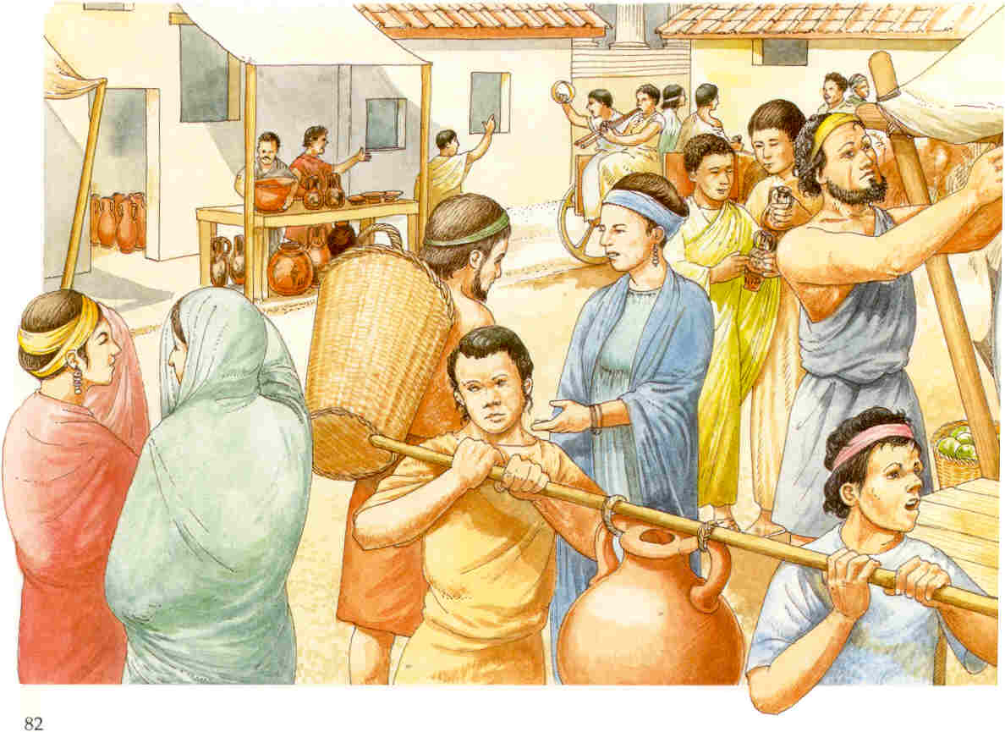
*Be sure you research information about the ANCIENT GREEKS (800-300 BCE) and their customs and culture NOT about modern Greeks.

Websites to get you started:

http://www.ancientgreece.com/s/Main_Page/
http://www.penn.museum/sites/greek_world/
http://www.pbs.org/empires/thegreeks/htmlver/
http://greece.mrdonn.org/
http://www.historyforkids.org/learn/greeks/
http://www.primaryhomeworkhelp.co.uk/Greece.html
http://www.ngkids.co.uk/did-you-know/10-facts-about-the-Ancient-Greeks

