Name
Blocks
Guns, Germs & Steel
Episode 1 Viewing Guide
PART 1: Yali’s Question

- What is Yali’s question? What is Yali really asking?

- What is “cargo”? How does this relate to POWER?

PART 2: Time of Equality
- When were all humans on Earth equal? Describe their lifestyle.

- Why is hunting (and gathering) so inefficient? How does this explain why hunter-gatherer societies don’t produce large civilizations?

- Describe the food of Papa New Guinea. Can it be mass-produced? Can it be easily stored for long periods of time? Explain the challenges this poses to feeding a civilization.

- How were the plants of the Middle East different? In what ways were these plants better?

PART 3: An Agricultural Revolution

- How old is the first farming village?

- What was the secret to sustaining a settled community?

- What grains were stored here? What characteristics to these grains have?

- Describe the process used to domesticate crops and create plants that produced bigger, better harvests.

- Why is farming a “decisive” point in human history?

- Where did farming first emerge on the planet and what did they grow?

- What were the effects of farming in these places?

- Why didn’t Papua New Guinea develop a large-scale civilization if they, too, had farming?

PART 3: The Luck of the Draw

- What is GEOGRAPHIC LUCK?

- Describe the process of animal domestication and the benefits this brought.

- How are domesticated crops and domesticated animals mutually beneficial for each other?

- What art the characteristics of animals that are suitable for domestication?

- List all of the animals that can be domesticated and where they can be found in the world.

- Where are these 14 animal species found? Describe how the theory about geographic luck applies to animals.

PART 4: From Tools to Cities

- How is fire, yet again, a game-changer for people living in early civilizations?

- Why did people in Papua New Guinea never develop advanced technology like metalworking?

- How did people of the Fertile Crescent lose their “head start”? Where did these entire communities, ideas, advances, etc. move to?

- Describe the shape Eurasia (east-west or north-south). What do places of the same latitude share?

- According to Jared Diamond, what are the three major elements that determine the “haves” and the “have nots” or the people who have more power in the world?

- How does having GEOGRAPHIC LUCK lead to a HEAD START?

PART 5: Epilogue
- Jared Diamond says that a when it comes to a civilization’s ability to gain power, wealth and strength, “…what is far more important is the hand people have been dealt, the raw materials they’ve had at their disposal [their geographic luck].” Explain how this theory works in your own words.

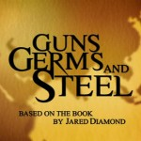
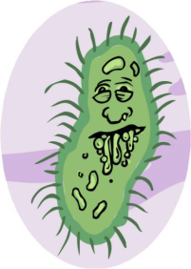
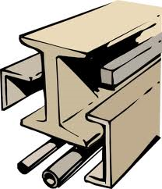
Guns, Germs & Steel

Predictions
Make predictions about how guns, germs and steel relate to geography and power.

Questioning
Write 2-3 questions that you have right off the bat about the theory of Guns, Germs and Steel and their relationship to power.

Mapping
As you watch:
- Label each continent/region
- Identify the movement of the early civilizations of the fertile crescent
- Put a tally mark where people were able to domesticate plants and farm mass produced food
- Put a tally mark for each domesticated animal on the continent where it’s found
- Put a large B for books where the first libraries were found
- Put a large GERM where people first became sick from major diseases/viruses and developed immunities
- Put a large S where steel
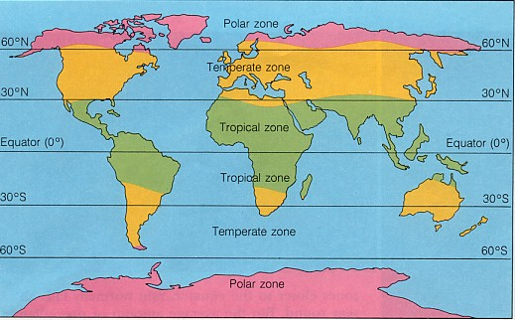
- `Put a large GUN where people first developed guns.

