Fishing for Data

Read the claim about the theme of duty below. This claim is an arguable and supportable statement but it cannot stand alone. You must choose data from the fishing pool below to support that claim. Be careful to choose only the data that seems to specifically connect to Homer’s emphasis of duty. Be prepared to explain (warrant) your reasoning.
Throughout the Illiad and the Odyssey, Homer emphasizes the importance of duty.

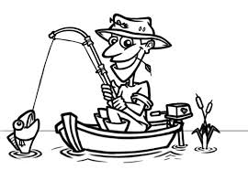
Odysseus addresses the ghosts in the underworld, vowing to slaughter his best heifer before she calved (11.1)
“We are Achaeans, blown off course by shifting gales on the Great South Sea” (Homer 9.249).
“We lit a fire, burnt an offering…and then sat in silence…waiting” (Homer 9.219).
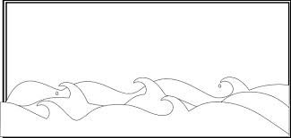
Claim:
At the beginning of the poem, Homer invokes the help of the muses to help him tell his story (1.1)
“My [Odysseus’s] home is on the peaked sea mark of Ithaca, under mount Neion’s wind-blown robe of leaves…” (9.10)
Calypso tells Odysseus that he is free to go and that she will help him to build a raft.
Calypso wants Odysseus to stay with her.
Odysseus makes sacrifices to the gods in the Odyssey.
Odysseus pretends to be crazy in order to avoid going to battle in Troy.

