Arab Spring Stations

- Collage Station
Study all the collages that we made last class. Generate at least 5 statements/questions using the following sentence starters:
  - This made me think of…
  - This connects to…
  - This makes me wonder…
  - How…
  - Why…
  - I am shocked by…
  - What if…
  - At first I thought ______, but now…
  - This is relevant to my life because…
  - I am amazed that…

- Political Cartoon Station. Choose 3-4 political cartoons. Follow the three steps below.
1. WOPAQ each cartoon:
    - Words, objects, people, actions and questions you have.
2. KTFD each cartoon:
- What does the artist want you to know, think, feel, do?
3. Make your own cartoon about the Arab Spring.

- TED Talk: How to Topple a Dictator Station. Think about the PILES of revolution.
- Which of PILES does Srdja Popovic address in his speech
- Note when this speech was recorded. What do you know about how the events have turned out? Let’s watch for this in this unit.
- Popovic addressed the Facebook revolution. What is his warning? Why does he worry about this?

- Jenga: Tipping Point Station
  - Play Jenga
  - Which Jenga piece was the one that toppled the whole tower?
  - How does this relate to the tipping point of a revolution?
  - There is just one piece that topples the tower—this piece represents the tipping point. BUT there are many other pieces out of place that make the tower unstable. How do you think this connects to the events leading to the tipping point of a revolution?
One Jenga piece was the tipping point for your experiment.
- What was the tipping point in the fight against Apartheid in South Africa?
- What was the tipping point in the American Revolution or the Civil Right Movement in the American South?
- What was the tipping point in Tunisia?
- Can you think of other tipping points?

- Middle East Map Station. Play with the map.
How does the geography explain the chronological order of revolutions in the Middle East/North Africa?
  - Connect the map to the domino cartoon below. How were the revolutions of the Arab Spring like a domino effect?
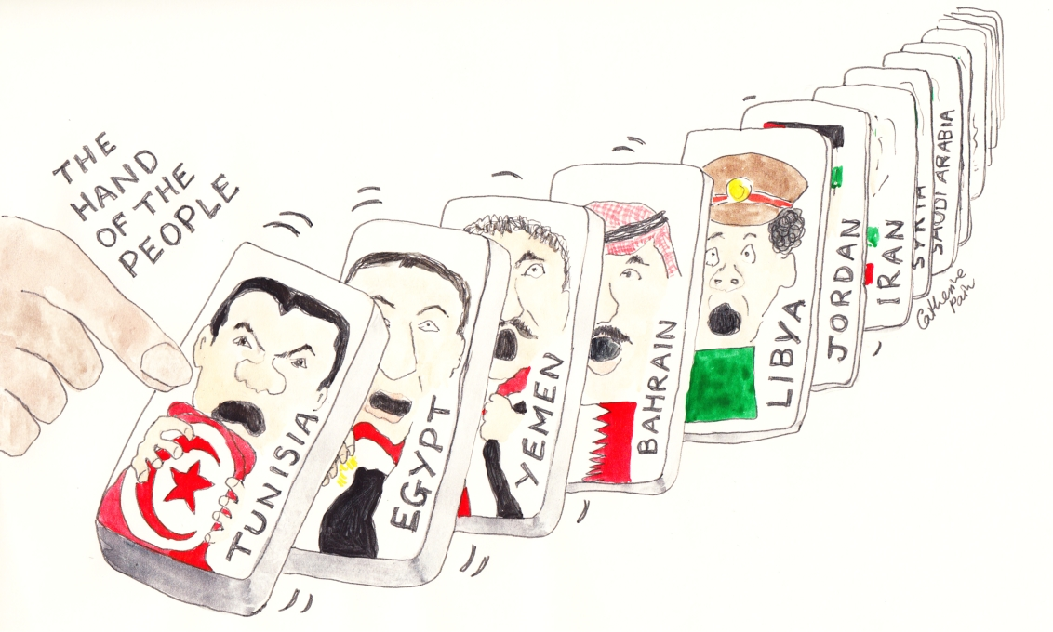

- Middle East Independent Novel/Memoir
  - Survey your book.
    - Why did you choose this book?
    - Figure out your deadlines and page numbers and write them down
    - Where and when is this book set?
    - What do you already know or think you know about the time and place?
    - Start reading!

